[**DIVIDE AND CONQUER**](http://118.185.187.137/moodle/course/view.php?id=158#section-1)

**AIM:**

To implement a C program using the Divide and Conquer strategy to count the number of zeros in an array of 1s and 0s, where all 1s appear before all 0s.

**PROGRAM:**

#include<stdio.h>

int main()

{

int m;

int count=0;

scanf("%d",&m);

int arr[m];

for(int i=0;i<m;i++)

{

scanf("%d",&arr[i]);

}

for(int i=0;i<m;i++)

{

if(arr[i]==0)

count++;

}

printf("%d",count);

}

**OUTPUT:**

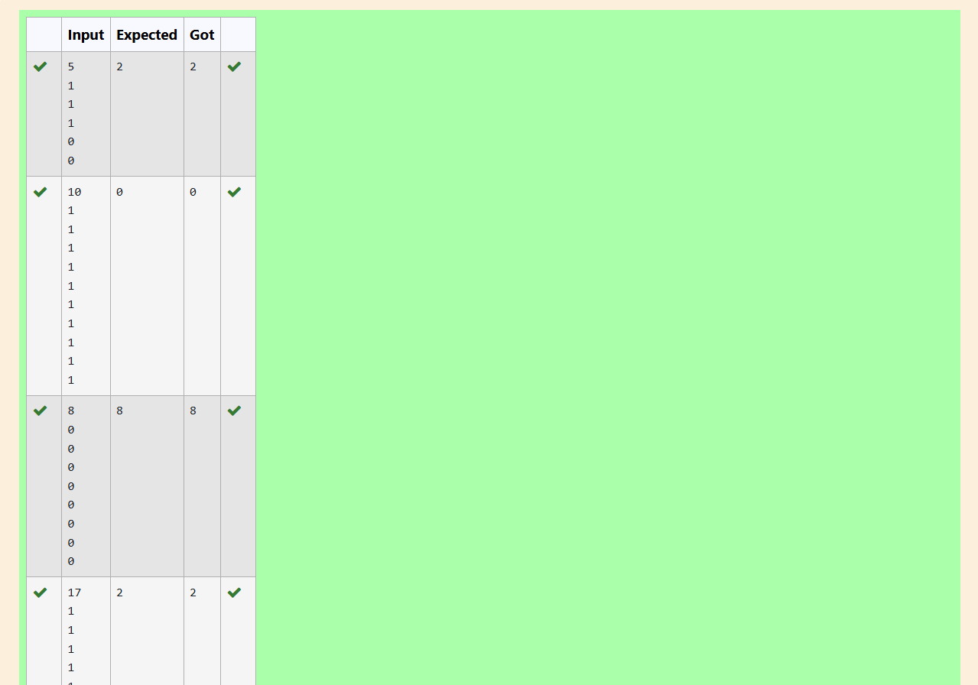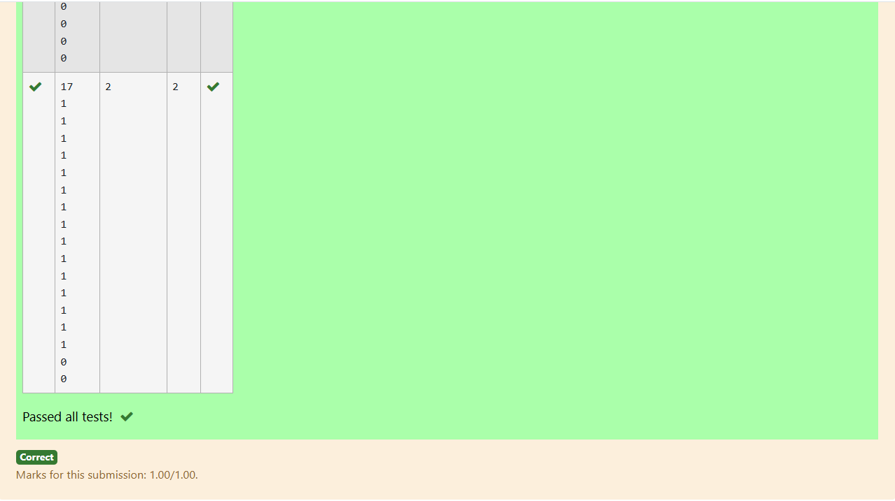

**AIM:**

To implement a C program that finds the majority element in a given array of integers, where the majority element appears more than ⌊n / 2⌋ times.

**PROGRAM:**

#include<stdio.h>

int main()

{

int n;

scanf("%d",&n);

int arr[n];

for(int i=0;i<n;i++)

{

scanf("%d",&arr[i]);

}

int arr1[n];

for(int i=0;i<n;i++)

{

int count=0;

for(int j=0;j<n;j++)

{

if(arr[i]==arr[j])

count++;

}

arr1[i]=count;

}

int max=arr1[0];

for(int i=1;i<n;i++)

{

if(arr1[i]>max)

max=arr1[i];

}

int indx=0;

for(int i=0;i<n;i++)

{

if(arr1[i]==max)

{

indx=i;

break;

}

}

printf("%d",arr[indx]);

}

**OUTPUT:**

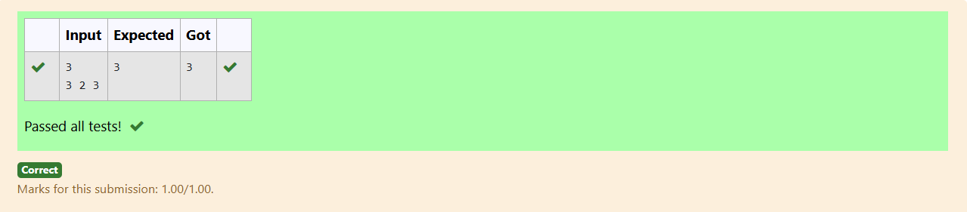

**AIM:**

To implement a C program using the Divide and Conquer strategy to find the floor of a given value x in a sorted array, where the floor is the largest element smaller than or equal to x.

**PROGRAM:**

#include<stdio.h>

int main()

{

int n;

scanf("%d",&n);

int arr[n];

for(int i=0;i<n;i++)

{

scanf("%d",&arr[i]);

}

int x;

scanf("%d",&x);

int max=arr[0];

for(int j=1;j<n;j++)

{

if(arr[j]>max && arr[j]<x)

max=arr[j];

}

printf("%d",max);

}

**OUTPUT:**

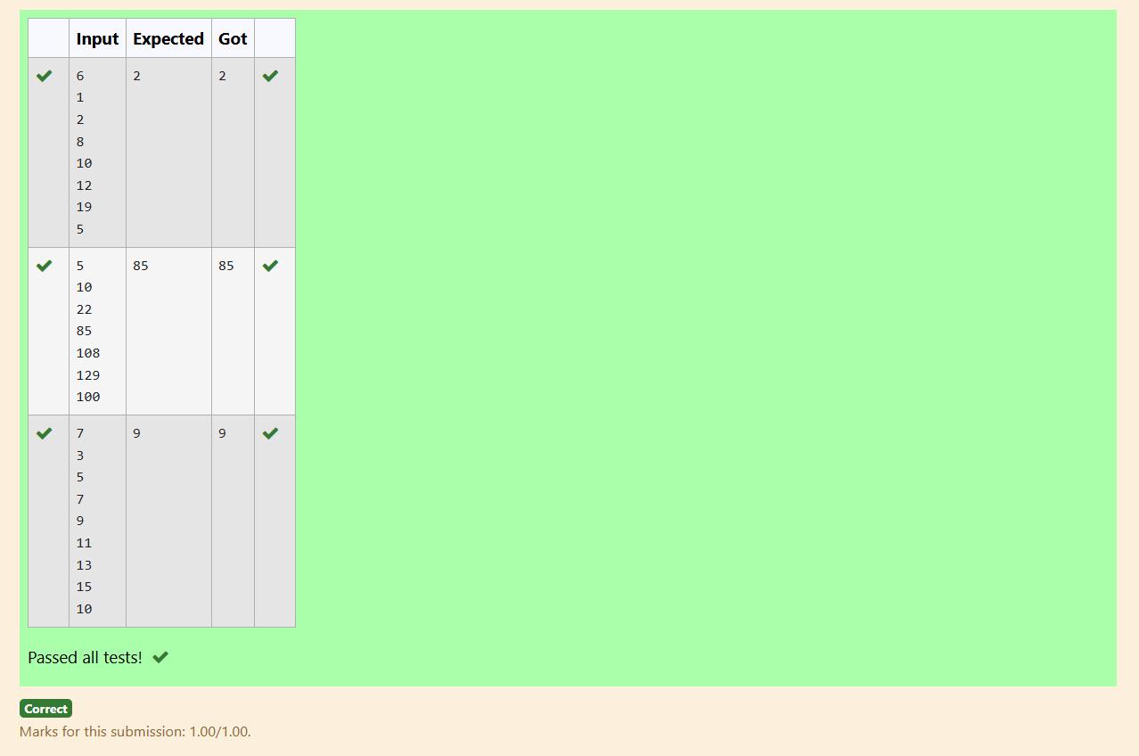

**AIM:**

To implement a C program using the Divide and Conquer strategy to check if there exist two elements in a sorted array whose sum equals a given number x, and return the elements if found, otherwise print "No".

**PROGRAM:**

#include<stdio.h>

int main()

{

int n;

scanf("%d",&n);

int arr[n];

for(int i=0;i<n;i++)

{

scanf("%d",&arr[i]);

}

int x;

scanf("%d",&x);

int flag;

for(int i=0;i<n;i++)

{

flag=0;

for(int j=0;j<n;j++)

{

if(arr[i]+arr[j]==x)

{

printf("%d\n",arr[i]);

printf("%d",arr[j]);

flag=1;

break;

}

}

if(flag==1)

break;

}

if(flag==0)

printf("No");

}

**OUTPUT:**

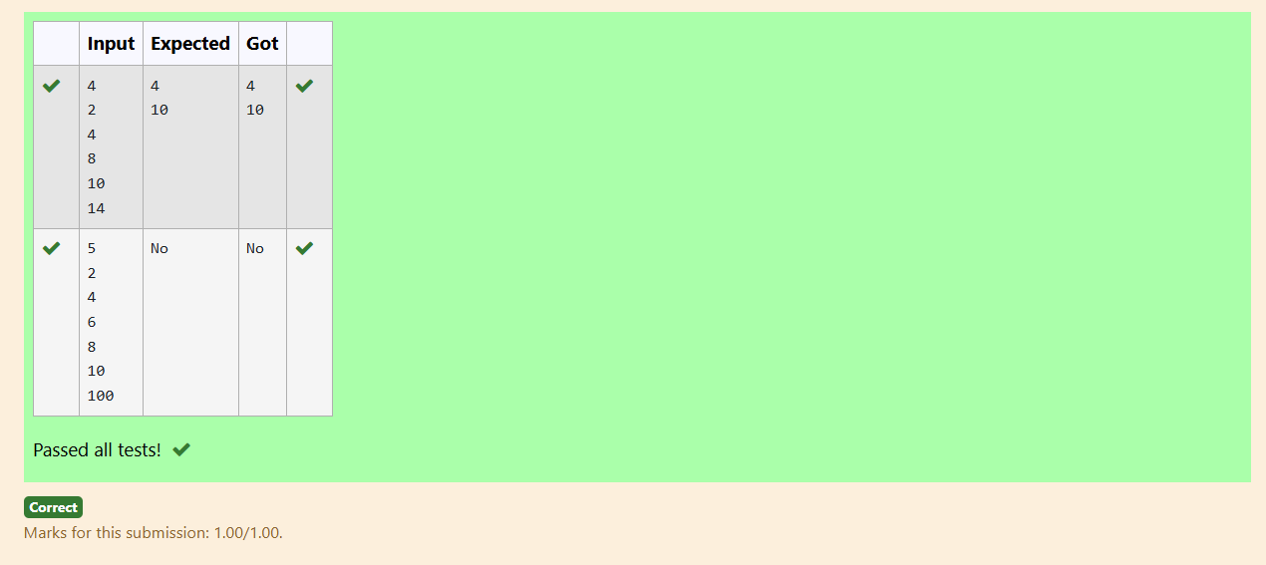

**AIM:**

To implement a C program to sort an array using the Quick Sort algorithm.

**PROGRAM:**

#include<stdio.h>

int main()

{

int n;

scanf("%d",&n);

int arr[n];

for(int i=0;i<n;i++)

{

scanf("%d",&arr[i]);

}

for(int i=0;i<n;i++)

{

for(int j=0;j<n;j++)

{

if(arr[i]<arr[j])

{

int temp=arr[i];

arr[i]=arr[j];

arr[j]=temp;

}

}

}

for(int i=0;i<n;i++)

{

printf("%d ",arr[i]);

}

}

**OUTPUT:**

